SMART JOB PORTAL

PROJECT REPORT

Submitted by

Jeevanantham R
Mukesh Kumar B

Project Guide

Vijaya K

Course

Advanced Java Programming

Nov 2025
ABSTRACT
The Online Food Ordering & Delivery Management System is designed to simplify the process of ordering food online. This project provides users with access to restaurants, menu items, and an ordering interface, while maintaining secure data processing through Hibernate ORM and MySQL. The application follows a layered architecture with clear separation between UI, Service, DAO, and Model components.

INTRODUCTION
With increased digitalization, job portals have become an essential medium for connecting job seekers and employers. Traditional recruitment involves manual communication, limited reach, and slow processing. This Smart Job Portal provides a structured and automated approach to improve job searching and hiring efficiency.
The system supports job posting, job listing, job application management, and user/company authentication using Hibernate and MySQL.

PROBLEM STATEMENT
The traditional job search and hiring process faces challenges such as:
- Limited access to available job opportunities
- Manual processing of applications
- Lack of centralized system for companies and job seekers
- Inefficient communication between applicants and employers
A digital job portal is required to automate the process, improve transparency, reduce delays, and provide a structured recruitment experience.
PROJECT OBJECTIVES

To develop a job portal that allows users to register, log in, and apply for jobs.

To enable companies to post jobs and manage their listings.

To implement secure authentication using Hibernate + MySQL.

To maintain organized job and application data through ORM-based mapping.

To provide a user-friendly console interface enhanced with ANSI colors.

To ensure separation of concerns using the DAO design pattern.

SCOPE OF THE PROJECT

The project supports:
- User and company authentication
- Job posting
- Job listing
- Applying for jobs
- Viewing applications
- Basic reporting for companies and users

MODULES OF SYSTEM
1. User Module
- User registration
- User login
- View available jobs
- Apply for job
- View applied jobs
2. Company Module
- Company registration
- Login for companies
- Post job
- View posted jobs
- Track applications (optional future enhancement)
3. Job Management Module
- Job creation
- Job listing
- Job retrieval by ID
- Linking job with its respective company

4. Application Module
- Apply for job
- View application status
- Manage application records
5. Utility & Configuration Module
- Hibernate configuration
- Database connection
- Console UI formatting (ANSI color support)

SYSTEM ARCHITECTURE

The project follows a 4-layer modular architecture for maintainability and scalability.

1. Presentation/UI Layer
Handles user interaction through the console using:
  - MainApp
  - UserMenu
  - CompanyMenu

2. DAO Layer

Contains database operations:
  - UserDao
  - CompanyDao
  - JobDao
  - ApplicationDao

3. ORM Layer (Hibernate)

Maps Java objects to MySQL tables using:

HibernateUtil

EntityClass

4. Database Layer
Stores persistent data using MySQL tables.

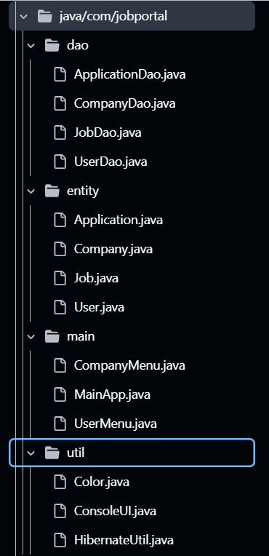

ER DIAGRAM
Entities involved:
- User
- Company
- Job
- Application
Relationships:
- One Company → Many Jobs
- One Job → Many Applications
- One User → Many Applications
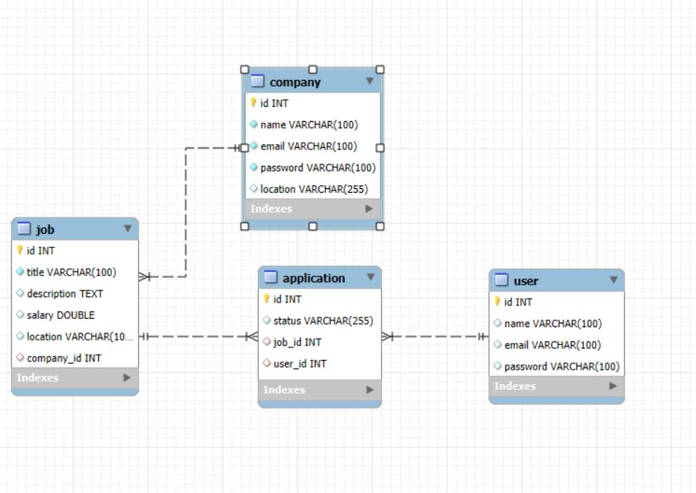

TECHNOLOGY USED
Layer / Component | Technology
Language | Java (JDK 8+)
ORM | Hibernate 5.x
Database | MySQL
Build Tool | Maven
Architecture | DAO Pattern
UI | Console + ANSI Colors
IDE | Eclipse

DATABASE DESIGN

Tables Used
- users – stores user details
- companies – stores company profiles
- jobs – stores job listings
- applications – stores job applications

Key Relationships
- company_id in jobs → foreign key to companies
- job_id and user_id in applications → foreign keys

TESTING
Manual testing techniques were applied, including:
- Authentication testing (valid/invalid login)
- Empty input validation
- Job posting and retrieval testing
- Application status tests
- Database integration tests
- Exception handling tests
All modules were validated for real-time database syncing using MySQL.

FUTURE ENHANCEMENTS
- Add admin dashboard
- Resume upload and automatic parsing
- Job recommendations using ML
- Email/SMS notification system
- Advanced search and filtering
- Company-side application review panel

OUTPUT
- User Registration
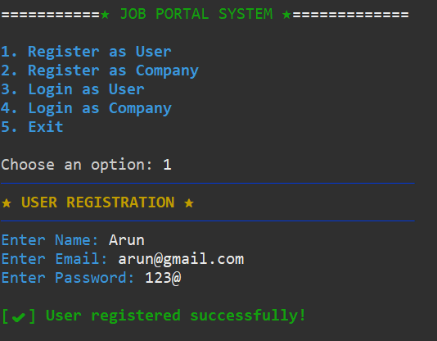

- Login Page
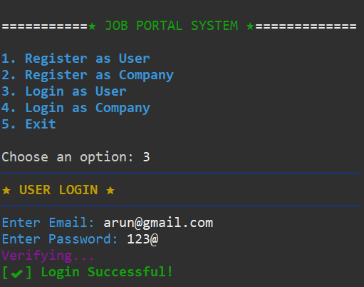

- User Dashboard
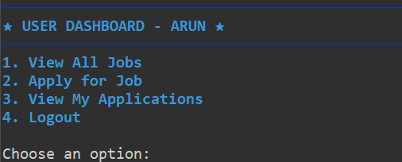

- Company Registration
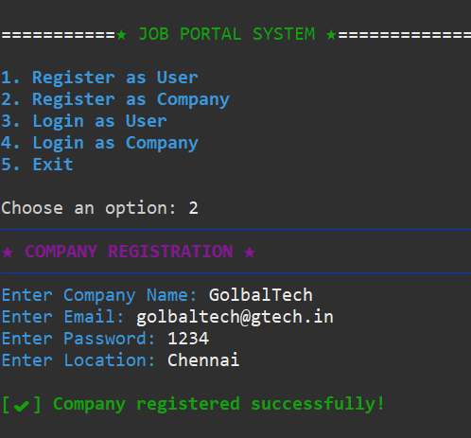

- Company Login

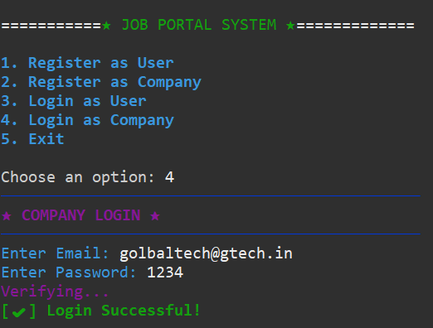

- Company Dashboard

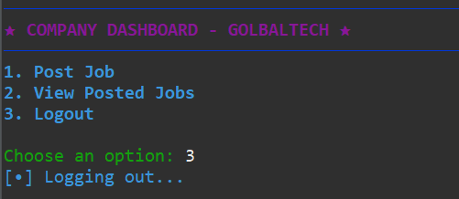

CONCLUSION
The Smart Job Portal System provides a simplified and effective platform for job seekers and employers. Using Hibernate ORM ensures secure data mapping and reduces SQL complexity.
The project is scalable and can be expanded into a full-fledged job portal with additional features like resume handling, notifications, and web-based UI.
This system demonstrates strong concepts in Java, Hibernate, MySQL, console UI design, and layered architecture.

--- END OF REPORT ---

